LO1
privacy, authentication, integrity, Non-repudiation,
nformation security is the practice of protecting information by mitigating information risks. It involves the protection of information systems and the information processed, stored and transmitted by these systems from unauthorized access, use, disclosure, disruption, modification or destruction. This includes the protection of personal information, financial information, and sensitive or confidential information stored in both digital and physical forms. Effective information security requires a comprehensive and multi-disciplinary approach, involving people, processes, and technology.
Information Security is not only about securing information from unauthorized access. Information Security is basically the practice of preventing unauthorized access, use, disclosure, disruption, modification, inspection, recording or destruction of information. Information can be a physical or electronic one. Information can be anything like Your details or we can say your profile on social media, your data on mobile phone, your biometrics etc. Thus Information Security spans so many research areas like Cryptography, Mobile Computing, Cyber Forensics, Online Social Media, etc.
During First World War, Multi-tier Classification System was developed keeping in mind the sensitivity of the information. With the beginning of Second World War, formal alignment of the Classification System was done. Alan Turing was the one who successfully decrypted Enigma Machine which was used by Germans to encrypt warfare data.
Effective information security requires a comprehensive approach that considers all aspects of the information environment, including technology, policies and procedures, and people. It also requires ongoing monitoring, assessment, and adaptation to address emerging threats and vulnerabilities.
Why we use Information Security?
We use information security to protect valuable information assets from a wide range of threats, including theft, espionage, and cybercrime. Information security is necessary to ensure the confidentiality, integrity, and availability of information, whether it is stored digitally or in other forms such as paper documents. Here are some key reasons why information security is important:
- Protecting sensitive information: Information security helps protect sensitive information from being accessed, disclosed, or modified by unauthorized individuals. This includes personal information, financial data, and trade secrets, as well as confidential government and military information.
- Mitigating risk: By implementing information security measures, organizations can mitigate the risks associated with cyber threats and other security incidents. This includes minimizing the risk of data breaches, denial-of-service attacks, and other malicious activities.
- Compliance with regulations: Many industries and jurisdictions have specific regulations governing the protection of sensitive information. Information security measures help ensure compliance with these regulations, reducing the risk of fines and legal liability.
- Protecting reputation: Security breaches can damage an organization’s reputation and lead to lost business. Effective information security can help protect an organization’s reputation by minimizing the risk of security incidents.
- Ensuring business continuity: Information security helps ensure that critical business functions can continue even in the event of a security incident. This includes maintaining access to key systems and data, and minimizing the impact of any disruptions.
Information Security programs are build around 3 objectives, commonly known as CIA – Confidentiality, Integrity, Availability.
- Confidentiality – means information is not disclosed to unauthorized individuals, entities and process. For example if we say I have a password for my Gmail account but someone saw while I was doing a login into Gmail account. In that case my password has been compromised and Confidentiality has been breached.
- Integrity – means maintaining accuracy and completeness of data. This means data cannot be edited in an unauthorized way. For example if an employee leaves an organisation then in that case data for that employee in all departments like accounts, should be updated to reflect status to JOB LEFT so that data is complete and accurate and in addition to this only authorized person should be allowed to edit employee data.
- Availability – means information must be available when needed. For example if one needs to access information of a particular employee to check whether employee has outstanded the number of leaves, in that case it requires collaboration from different organizational teams like network operations, development operations, incident response and policy/change management.
Denial of service attack is one of the factor that can hamper the availability of information.
Apart from this there is one more principle that governs information security programs. This is Non repudiation.
- Non repudiation – means one party cannot deny receiving a message or a transaction nor can the other party deny sending a message or a transaction. For example in cryptography it is sufficient to show that message matches the digital signature signed with sender’s private key and that sender could have a sent a message and nobody else could have altered it in transit. Data Integrity and Authenticity are pre-requisites for Non repudiation.
- Authenticity – means verifying that users are who they say they are and that each input arriving at destination is from a trusted source.This principle if followed guarantees the valid and genuine message received from a trusted source through a valid transmission. For example if take above example sender sends the message along with digital signature which was generated using the hash value of message and private key. Now at the receiver side this digital signature is decrypted using the public key generating a hash value and message is again hashed to generate the hash value. If the 2 value matches then it is known as valid transmission with the authentic or we say genuine message received at the recipient side
- Accountability – means that it should be possible to trace actions of an entity uniquely to that entity. For example as we discussed in Integrity section Not every employee should be allowed to do changes in other employees data. For this there is a separate department in an organization that is responsible for making such changes and when they receive request for a change then that letter must be signed by higher authority for example Director of college and person that is allotted that change will be able to do change after verifying his bio metrics, thus timestamp with the user(doing changes) details get recorded. Thus we can say if a change goes like this then it will be possible to trace the actions uniquely to an entity.

advantages to implementing an information classification system in an organization’s information security program:
- Improved security: By identifying and classifying sensitive information, organizations can better protect their most critical assets from unauthorized access or disclosure.
- Compliance: Many regulatory and industry standards, such as HIPAA and PCI-DSS, require organizations to implement information classification and data protection measures.
- Improved efficiency: By clearly identifying and labeling information, employees can quickly and easily determine the appropriate handling and access requirements for different types of data.
- Better risk management: By understanding the potential impact of a data breach or unauthorized disclosure, organizations can prioritize resources and develop more effective incident response plans.
- Cost savings: By implementing appropriate security controls for different types of information, organizations can avoid unnecessary spending on security measures that may not be needed for less sensitive data.
- Improved incident response: By having a clear understanding of the criticality of specific data, organizations can respond to security incidents in a more effective and efficient manner.
There are some potential disadvantages to implementing an information classification system in an organization’s information security program:
- Complexity: Developing and maintaining an information classification system can be complex and time-consuming, especially for large organizations with a diverse range of data types.
- Cost: Implementing and maintaining an information classification system can be costly, especially if it requires new hardware or software.
- Resistance to change: Some employees may resist the implementation of an information classification system, especially if it requires them to change their usual work habits.
- Inaccurate classification: Information classification is often done by human, so it is possible that some information may be misclassified, which can lead to inadequate protection or unnecessary restrictions on access.
- Lack of flexibility: Information classification systems can be rigid and inflexible, making it difficult to adapt to changing business needs or new types of data.
- False sense of security: Implementing an information classification system may give organizations a false sense of security, leading them to overlook other important security controls and best practices.
- Maintenance: Information classification should be reviewed and updated frequently, if not it can become outdated and ineffective.
Uses of Information Security :
Information security has many uses, including:
- Confidentiality: Keeping sensitive information confidential and protected from unauthorized access.
- Integrity: Maintaining the accuracy and consistency of data, even in the presence of malicious attacks.
- Availability: Ensuring that authorized users have access to the information they need, when they need it.
- Compliance: Meeting regulatory and legal requirements, such as those related to data privacy and protection.
- Risk management: Identifying and mitigating potential security threats to prevent harm to the organization.
- Disaster recovery: Developing and implementing a plan to quickly recover from data loss or system failures.
- Authentication: Verifying the identity of users accessing information systems.
- Encryption: Protecting sensitive information from unauthorized access by encoding it into a secure format.
- Network security: Protecting computer networks from unauthorized access, theft, and other types of attacks.
- Physical security: Protecting information systems and the information they store from theft, damage, or destruction by securing the physical facilities that house these systems.
Issues of Information Security :
Information security faces many challenges and issues, including:
- Cyber threats: The increasing sophistication of cyber attacks, including malware, phishing, and ransomware, makes it difficult to protect information systems and the information they store.
- Human error: People can inadvertently put information at risk through actions such as losing laptops or smartphones, clicking on malicious links, or using weak passwords.
- Insider threats: Employees with access to sensitive information can pose a risk if they intentionally or unintentionally cause harm to the organization.
- Legacy systems: Older information systems may not have the security features of newer systems, making them more vulnerable to attack.
- Complexity: The increasing complexity of information systems and the information they store makes it difficult to secure them effectively.
- Mobile and IoT devices: The growing number of mobile devices and internet of things (IoT) devices creates new security challenges as they can be easily lost or stolen, and may have weak security controls.
- Integration with third-party systems: Integrating information systems with third-party systems can introduce new security risks, as the third-party systems may have security vulnerabilities.
- Data privacy: Protecting personal and sensitive information from unauthorized access, use, or disclosure is becoming increasingly important as data privacy regulations become more strict.
- Globalization: The increasing globalization of business makes it more difficult to secure information, as data may be stored, processed, and transmitted across multiple countries with different security requirements.

LO7
IDS and IPS
Intrusion Prevention System is also known as Intrusion Detection and Prevention System. It is a network security application that monitors network or system activities for malicious activity. Major functions of intrusion prevention systems are to identify malicious activity, collect information about this activity, report it and attempt to block or stop it.
Intrusion prevention systems are contemplated as augmentation of Intrusion Detection Systems (IDS) because both IPS and IDS operate network traffic and system activities for malicious activity.
IPS typically record information related to observed events, notify security administrators of important observed events and produce reports. Many IPS can also respond to a detected threat by attempting to prevent it from succeeding. They use various response techniques, which involve the IPS stopping the attack itself, changing the security environment or changing the attack’s content.
How Does an IPS Work?
An IPS works by analyzing network traffic in real-time and comparing it against known attack patterns and signatures. When the system detects suspicious traffic, it blocks it from entering the network.
Types of IPS
There are two main types of IPS:
- Network-Based IPS: A Network-Based IPS is installed at the network perimeter and monitors all traffic that enters and exits the network.
- Host-Based IPS: A Host-Based IPS is installed on individual hosts and monitors the traffic that goes in and out of that host.
Why Do You Need an IPS?
An IPS is an essential tool for network security. Here are some reasons why:
- Protection Against Known and Unknown Threats: An IPS can block known threats and also detect and block unknown threats that haven’t been seen before.
- Real-Time Protection: An IPS can detect and block malicious traffic in real-time, preventing attacks from doing any damage.
- Compliance Requirements: Many industries have regulations that require the use of an IPS to protect sensitive information and prevent data breaches.
- Cost-Effective: An IPS is a cost-effective way to protect your network compared to the cost of dealing with the aftermath of a security breach.
- Increased Network Visibility: An IPS provides increased network visibility, allowing you to see what’s happening on your network and identify potential security risks.
Classification of Intrusion Prevention System (IPS):
Intrusion Prevention System (IPS) is classified into 4 types:
- Network-based intrusion prevention system (NIPS):
It monitors the entire network for suspicious traffic by analyzing protocol activity.
- Wireless intrusion prevention system (WIPS):
It monitors a wireless network for suspicious traffic by analyzing wireless networking protocols.
- Network behavior analysis (NBA):
It examines network traffic to identify threats that generate unusual traffic flows, such as distributed denial of service attacks, specific forms of malware and policy violations.
- Host-based intrusion prevention system (HIPS):
It is an inbuilt software package which operates a single host for doubtful activity by scanning events that occur within that host.
Comparison of Intrusion Prevention System (IPS) Technologies:
The Table below indicates various kinds of IPS Technologies:
IPS Technology Type | Types of Malicious Activity Detected | Scope per Sensor | Strengths
Network-Based | Network, transport, and application TCP/IP layer activity | Multiple network subnets  and groups of hosts | Only IDPS which can analyze the widest range of application protocols;
Wireless | Wireless protocol activity; unauthorized wireless  local area networks (WLAN) in use | Multiple WLANs and  groups of wireless clients | Only IDPS able to predict wireless protocol activity
NBA | Network, transport, and application TCP/IP layer activity  that causes anomalous network flows | Multiple network subnets  and groups of hosts | Typically more effective than the others at  identifying reconnaissance scanning and  DoS attacks, and at reconstructing major  malware infections
Host-Based | Host application and operating system (OS) activity; network, transport,  and application TCP/IP layer activity | Individual host | Can analyze activity that  was transferred in end-to-end  encrypted communications
Detection Method of Intrusion Prevention System (IPS):
- Signature-based detection:
Signature-based IDS operates packets in the network and compares with pre-built and preordained attack patterns known as signatures.
- Statistical anomaly-based detection:
Anomaly based IDS monitors network traffic and compares it against an established baseline. The baseline will identify what is normal for that network and what protocols are used. However, It may raise a false alarm if the baselines are not intelligently configured.
- Stateful protocol analysis detection:
This IDS method recognizes divergence of protocols stated by comparing observed events with pre-built profiles of generally accepted definitions of not harmful activity.
Comparison of IPS with IDS:
The main difference between Intrusion Prevention System (IPS) with Intrusion Detection Systems (IDS) are:
- Intrusion prevention systems are placed in-line and are able to actively prevent or block intrusions that are detected.
- IPS can take such actions as sending an alarm, dropping detected malicious packets, resetting a connection or blocking traffic from the offending IP address.
- IPS also can correct cyclic redundancy check (CRC) errors, defragment packet streams, mitigate TCP sequencing issues and clean up unwanted transport and network layer options.
Conclusion:
An Intrusion Prevention System (IPS) is a crucial component of any network security strategy. It monitors network traffic in real-time, compares it against known attack patterns and signatures, and blocks any malicious activity or traffic that violates network policies. An IPS is an essential tool for protecting against known and unknown threats, complying with industry regulations, and increasing network visibility. Consider implementing an IPS to protect your network and prevent security breaches.

Operating System Security
Protection refers to a mechanism that controls the access of programs, processes, or users to the resources defined by a computer system. We can take protection as a helper to multiprogramming operating systems so that many users might safely share a common logical namespace such as a directory or files.
Security can be attacked in the following ways:
- Authorization
- Browsing
- Trap doors
- Invalid Parameters
- Line Tapping
- Electronic Data Capture
- Lost Line
- Improper Access Controls
- Waste Recovery
- Rogue Software

Operating Systems Employ Security and Protection
Measures to prevent a person from illegally using resources in a computer system, or interfering with them in any manner. These measures ensure that data and programs are used only by authorized users and only in a desired manner, and that they are neither modified nor denied to authorized users. Security measures deal with threats to resources that come from outside a computer system, while protection measures deal with internal threats. Passwords are the principal security tool.
A password requirement thwarts attempts by unauthorized persons to masquerade as legitimate users of a system. The confidentiality of passwords is upheld by encryption. Computer users need to share data and programs stored in files with collaborators, and here is where an operating system’s protection measures come in.
The owner of a file informs the OS of the specific access privileges other users are to have—whether and how others may access the file. The operating system’s protection function then ensures that all accesses to the file are strictly in accordance with the specified access privileges. We begin by discussing how different kinds of security breaches are carried out: Trojan horses, viruses, worms, and buffer overflows. Their description is followed by a discussion of encryption techniques. We then describe three popular protection structures called access control lists, capability lists, and protection domains, and examine the degree of control provided by them over sharing of files. In the end, we discuss how security classifications of computer systems reflect the degree to which a system can withstand security and protection threats
Security measures guard a user’s data and programs against interference from persons or programs outside the operating system; we broadly refer to such persons and their programs as nonusers.

Buffer Overflow Technique
The buffer overflow technique can be employed to force a server program to execute an intruder-supplied code to breach the host computer system’s security. It has been used to a devastating effect in mail servers and other Web servers.
The basic idea in this technique is simple: Most systems contain a fundamental vulnerability—some programs do not validate the lengths of inputs they receive from users or other programs.
Because of this vulnerability, a buffer area in which such input is received may overflow and overwrite contents of adjoining areas of memory. On hardware platforms that use stacks that grow downward in memory e.g., the Intel 80×86 architecture, such overflows provide an opportunity to execute a piece of code that is disguised as data put in the buffer. This code could launch a variety of security attacks

How a buffer overflow can be used to launch a security attack?
1. The stack grows downward, i.e., toward smaller addresses in memory. It looks as shown on the left before the currently executing function calls the function sample.
2. The code of the calling function pushes a return address and two parameters of sample onto the stack. Each of these occupies four bytes.
3. The code of sample allocates the variable beta and other variables on the stack. The stack now looks as shown on the right. Notice that the start address of beta is at the low end of the memory allocated to it. The end address of beta adjoins the last byte of the parameters.
4. The function sample copies 412 bytes into the variable beta. The first 408 bytes contain code whose execution would cause a security violation. Bytes 409–412 contain the start address of this code. These four bytes overwrite the return address in the stack.
5. The function sample executes a return statement. Control is transferred to the address found in the stack entry that is expected to contain the return address. Effectively, the code in variable beta is invoked. It executes with the privileges of the calling function.
1. Authorization: It means verification of access to the system resources. Intruders may guess or steal password and use it. Intruder may use a vendor-supplied password, which is expected to use by system administrator. It may find password by trial and error method. If the user logs on and goes for a break then the intruder may use the terminal. An intruder can write a dummy login program to fool user and that program collects information for its use later on.
2. Authentication: Authentication is verification of a user’s identity. Operating systems most often perform authentication by knowledge. That is, a person claiming to be some user X is called upon to exhibit some knowledge shared only between the OS and user X, such as a password
3. Browsing: Files are very permissive so one can easily browse system files. Due to that it may access database and confidential information can be read.
4. Trap doors: Sometimes Software designers want to modify their programs after installation. for that there are some secret entry points which programmers keep and it does not require and permission . These are called trap doors. Intrudes can use these trap doors.
5. Invalid Parameters: Due to invalid parameters some security violation can take place.
6. Line Tapping: Tapings in the communication line can access or modify confidential data.
7. Electronic data capture: Using wiretaps or mechanism to pick up screen radiation and recognize what is displayed on screen is termed electronic data capture.
8. Lost Line: In networking, the line way gets lost. In such case some o/s log out and allow access only after correct identify of user. some o/s cannot do this. So process will be floating and allow intruder to access data.
9. Improper Access Controls: Some administrators may not plan about all rights. So some users may have more access and some users have very less access.
10. Waste Recovery: If the block is deleted its information will be as it is. until it is allocated to another file. Intruder may use some mechanism to scan these blocks.
11. Rogue Software: Programs are written to create mischief . Some of the programs under this are as follows:
- Trojan Horse: These programs seem to be harmless but actually harmful.
- Chameleon: It is similar to a Trojan horse. It is mimic logon program to collect all valid usernames and passwords on a system.
- Ordinary Software Bomb: It explodes as soon as it is executed.
- Timed S/W: It becomes active only at specific time.
- Logical S/W: It is activated only if logical condition is satisfied.
- Worms: Programs attacking on node and spreading to other nodes.
- Virus: It gets attacked to other programs to cause damage.

LO8
Types of Malware
Malware is short for malicious software, and refers to any software that is designed to cause harm to computer systems, networks, or users. Malware can take many forms, including:
- Virus: A program that infects other software and replicates itself, spreading from one computer to another.
- Worm: A program that replicates itself and spreads over a network, without the need for a host file.
- Trojan: A program that appears to be legitimate but contains hidden malicious functionality.
- Ransomware: A program that encrypts a user’s files and demands payment in exchange for the decryption key.
- Adware: Software that displays unwanted ads on a user’s computer or device.
- Spyware: Software that collects information about a user’s computer usage and sends it to a third party without the user’s knowledge or consent.
- Rootkit: Software that provides an attacker with administrator-level access to a computer or network.
- Backdoor: A program that allows unauthorized access to a computer system.
- Keyloggers: A software program that records every keystroke made on a computer by the user.
- Fileless malware: A malicious software that operates on entire computer memory not leaving any files on a hard drive, making it difficult to detect and remove.
It’s important for individuals and organizations to be aware of the different types of malware and take steps to protect their systems, such as using antivirus software, keeping software and systems up-to-date, and being cautious when opening email attachments or downloading software from the internet.
Malware is a program designed to gain access to computer systems, normally for the benefit of some third party, without the user’s permission. Malware includes computer viruses, worms, Trojan horses, ransomware, spyware and other malicious programs.
Types of Malware:
- Viruses – A Virus is a malicious executable code attached to another executable file. The virus spreads when an infected file is passed from system to system. Viruses can be harmless or they can modify or delete data. Opening a file can trigger a virus. Once a program virus is active, it will infect other programs on the computer.
- Worms – Worms replicate themselves on the system, attaching themselves to different files and looking for pathways between computers, such as computer network that shares common file storage areas. Worms usually slow down networks. A virus needs a host program to run but worms can run by themselves. After a worm affects a host, it is able to spread very quickly over the network.
- Trojan horse – A Trojan horse is malware that carries out malicious operations under the appearance of a desired operation such as playing an online game. A Trojan horse varies from a virus because the Trojan binds itself to non-executable files, such as image files, audio files.
- Ransomware – Ransomware grasps a computer system or the data it contains until the victim makes a payment. Ransomware encrypts data in the computer with a key which is unknown to the user. The user has to pay a ransom (price) to the criminals to retrieve data. Once the amount is paid the victim can resume using his/her system
- Adware – It displays unwanted ads and pop-ups in computer. It comes along with software downloads and packages. It generate renenue for the software distributer by displaying ads.
- Spyware – Its purpose is to steal private information from a computer system for a third party. Spyware collects information and sends it to the hacker.
- Logic Bombs – A logic bomb is a malicious program that uses a trigger to activate the malicious code. The logic bomb remains non-functioning until that trigger event happens. Once triggered, a logic bomb implements a malicious code that causes harm to a computer. Cybersecurity specialists recently discovered logic bombs that attack and destroy the hardware components in a workstation or server including the cooling fans, hard drives, and power supplies. The logic bomb overdrives these devices until they overheat or fail.
- Rootkits – A rootkit modifies the OS to make a backdoor. Attackers then use the backdoor to access the computer distantly. Most rootkits take advantage of software vulnerabilities to modify system files.
- Backdoors – A backdoor bypasses the usual authentication used to access a system. The purpose of the backdoor is to grant the cyber criminals future access to the system even if the organization fixes the original vulnerability used to attack the system.
- Keyloggers – Keylogger records everything the user types on his/her computer system to obtain passwords and other sensitive information and send them to the source of the keylogging program.

Advantages of Detecting and Removing Malware:
- Improved Security: By detecting and removing malware, individuals and organizations can improve the security of their systems and reduce the risk of future infections.
- Prevent Data Loss: Malware can cause data loss, and by removing it, individuals and organizations can protect their important files and information.
- Protect Reputation: Malware can cause harm to a company’s reputation, and by detecting and removing it, individuals and organizations can protect their image and brand.
- Increased Productivity: Malware can slow down systems and make them less efficient, and by removing it, individuals and organizations can increase the productivity of their systems and employees.

Disadvantages of Detecting and Removing Malware:
- Time-Consuming: The process of detecting and removing malware can be time-consuming and require specialized tools and expertise.
- Cost: Antivirus software and other tools required to detect and remove malware can be expensive for individuals and organizations.
- False Positives: Malware detection and removal tools can sometimes result in false positives, causing unnecessary alarm and inconvenience.
- Difficulty: Malware is constantly evolving, and the process of detecting and removing it can be challenging and require specialized knowledge and expertise.
- Risk of Data Loss: Some malware removal tools can cause unintended harm, resulting in data loss or system instability.

Hacking Cracking and Sneaking

Hackers Vs. Crackers: Understand the Difference Between Hackers and Crackers
Both of these terms have a common connection- hacking. There is a fundamental difference between hackers and crackers, as both of them work for different purposes. In this article, we will discuss the ways in which both of these differ. But before we do that, let us first understand a bit more about hacking.

What is Hacking?
It is a form of planning or a technique that people use to get access to various unauthorized systems, software, and devices. In simpler words, hacking is the process of gaining access to a computer or a network that might not be legal or permitted for any random user. The people who master hacking are very skilled with computer systems and have a great deal of knowledge about various software and hardware devices.
The people who have hacking skills are basically of two types:
- Hackers
- Crackers

What are Hackers?
These are people who hack devices and systems with good intentions. They might hack a system for a specified purpose or for obtaining more knowledge out of it. Hackers work by finding loopholes in a given system and by covering these loopholes. They are basically programmers who gather extensive knowledge regarding programming languages and operating systems (OS). They never intend to harm, compromise, or damage any system data.

What are Crackers?
These are people who hack a system by breaking into it and violating it with some bad intentions. They may hack a system remotely for stealing the contained data or for harming it permanently. In simpler words, crackers destroy the data and information contained in a system by getting unauthorized access to its concerned network. They always keep their works hidden because what they do is illegal and mostly prohibited or forbidden. A cracker can easily bypass your device’s passwords, company websites, social media, personal bank details and can use those details for directly transferring money from your bank.

Difference Between Hackers and Crackers
Here is a list of the differences between Hackers and Crackers.
Parameters | Hackers | Crackers
Definition | Hackers are good people who hack devices and systems with good intentions. They might hack a system for a specified purpose or for obtaining more knowledge out of it. | Crackers are people who hack a system by breaking into it and violating it with some bad intentions. They may hack a system remotely for stealing the contained data or for harming it permanently.
Skills and Knowledge | They have advanced knowledge of programming languages and computer OS. Hackers are very skilled and intelligent people. | These people may be skilled. But most of the time, they don’t even need extensive skills. Some crackers only have a knowledge of a few illegal tricks that help them in stealing data.
Role in an Organization | Hackers work with specific organizations to help them in protecting their information and important data. They mainly provide organizations with expertise in security and internet safety. | Crackers harm an organization. These are the people from whom hackers defend sensitive data and protect the organizations as a whole.
Ethics | These are ethical types of professionals. | These are illegal and unethical types of people who only focus on benefiting themselves with their hacking.
Data Security | They protect the data and never steal or damage it. Their only intention is to gain knowledge from the concerned data and information. | They usually steal, delete, corrupt, or compromise the data they find from a system’s loopholes. Your data stays vulnerable in the hands of a cracker.
Use of Tools | Hackers use their own legal tools for checking network strength, establishing security, and protecting an organization from internet threats. | Crackers don’t have any tools of their own. They make use of someone else’s tools for performing illegal activities and harming/ compromising a system.
Network Strength | They help improve a network’s strength. | They harm and deplete a network’s strength.
Certification | They always have legal certificates for hacking, for example, XCEH certificates. Hackers have nothing to hide and perform legal activities. Thus, they need certification for the work they do. | They usually don’t have any certificates as they are unskilled. But some of them may even have certificates. Crackers usually refrain away from certification because they prefer staying anonymous about their work.

LO9
Introduction to firewalls, Types of Firewalls, Need of firewalls, Function of firewalls, enabling and disabling firewalls, User Management in firewall , VPN Security Basic functions of Antivirus, advantages and disadvantages of antivirus, Differentiate between Firewalls and Antivirus, some examples of ant viruses

Firewall Tutorial
Nowadays, it is a big challenge to protect our sensitive data from unwanted and unauthorized sources. There are various tools and devices that can provide different security levels and help keep our private data secure. One such tool is a 'firewall' that prevents unauthorized access and keeps our computers and data safe and secure.
PlayNext
Unmute
Current TimeÂ 0:00
/
DurationÂ 18:10
Loaded: 0.37%
Â
Fullscreen
Backward Skip 10sPlay VideoForward Skip 10s
In this article, we have talked about firewalls as well as other related topics, such as why we need firewalls, functions of firewalls, limitations of firewalls, working of firewalls, etc.

What is a Firewall?
A firewall can be defined as a special type of network security device or a software program that monitors and filters incoming and outgoing network traffic based on a defined set of security rules. It acts as a barrier between internal private networks and external sources (such as the public Internet).
The primary purpose of a firewall is to allow non-threatening traffic and prevent malicious or unwanted data traffic for protecting the computer from viruses and attacks. A firewall is a cybersecurity tool that filters network traffic and helps users block malicious software from accessing the Internet in infected computers.
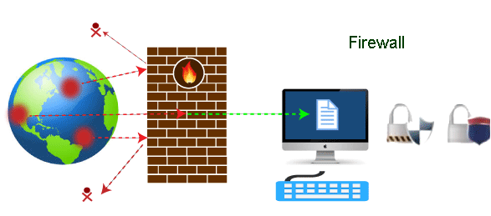

Firewall: Hardware or Software
This is one of the most problematic questions whether a firewall is a hardware or software. As stated above, a firewall can be a network security device or a software program on a computer. This means that the firewall comes at both levels, i.e., hardware and software, though it's best to have both.
Each format (a firewall implemented as hardware or software) has different functionality but the same purpose. A hardware firewall is a physical device that attaches between a computer network and a gateway. For example, a broadband router. On the other hand, a software firewall is a simple program installed on a computer that works through port numbers and other installed software.
Apart from that, there are cloud-based firewalls. They are commonly referred to as FaaS (firewall as a service). A primary advantage of using cloud-based firewalls is that they can be managed centrally. Like hardware firewalls, cloud-based firewalls are best known for providing perimeter security.

Why Firewall
Firewalls are primarily used to prevent malware and network-based attacks. Additionally, they can help in blocking application-layer attacks. These firewalls act as a gatekeeper or a barrier. They monitor every attempt between our computer and another network. They do not allow data packets to be transferred through them unless the data is coming or going from a user-specified trusted source.
Firewalls are designed in such a way that they can react quickly to detect and counter-attacks throughout the network. They can work with rules configured to protect the network and perform quick assessments to find any suspicious activity. In short, we can point to the firewall as a traffic controller.
Some of the important risks of not having a firewall are:

Open Access
If a computer is running without a firewall, it is giving open access to other networks. This means that it is accepting every kind of connection that comes through someone. In this case, it is not possible to detect threats or attacks coming through our network. Without a firewall, we make our devices vulnerable to malicious users and other unwanted sources.

Lost or Comprised Data
Without a firewall, we are leaving our devices accessible to everyone. This means that anyone can access our device and have complete control over it, including the network. In this case, cybercriminals can easily delete our data or use our personal information for their benefit.

Network Crashes
In the absence of a firewall, anyone could access our network and shut it down. It may lead us to invest our valuable time and money to get our network working again.
Therefore, it is essential to use firewalls and keep our network, computer, and data safe and secure from unwanted sources.

Brief History of Firewall
Firewalls have been the first and most reliable component of defense in network security for over 30 years. Firewalls first came into existence in the late 1980s. They were initially designed as packet filters. These packet filters were nothing but a setup of networks between computers. The primary function of these packet filtering firewalls was to check for packets or bytes transferred between different computers.
Firewalls have become more advanced due to continuous development, although such packet filtering firewalls are still in use in legacy systems.
As the technology emerged, Gil Shwed from Check Point Technologies introduced the first stateful inspection firewall in 1993. It was named as FireWall-1. Back in 2000, Netscreen came up with its purpose-built firewall 'Appliance'. It gained popularity and fast adoption within enterprises because of increased internet speed, less latency, and high throughput at a lower cost.
The turn of the century saw a new approach to firewall implementation during the mid-2010. The 'Next-Generation Firewalls' were introduced by the Palo Alto Networks. These firewalls came up with a variety of built-in functions and capabilities, such as Hybrid Cloud Support, Network Threat Prevention, Application and Identity-Based Control, and Scalable Performance, etc. Firewalls are still getting new features as part of continuous development. They are considered the first line of defense when it comes to network security.

How does a firewall work?
A firewall system analyzes network traffic based on pre-defined rules. It then filters the traffic and prevents any such traffic coming from unreliable or suspicious sources. It only allows incoming traffic that is configured to accept.
Typically, firewalls intercept network traffic at a computer's entry point, known as a port. Firewalls perform this task by allowing or blocking specific data packets (units of communication transferred over a digital network) based on pre-defined security rules. Incoming traffic is allowed only through trusted IP addresses, or sources.
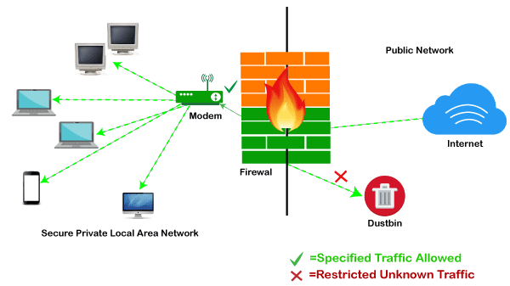

Functions of Firewall
As stated above, the firewall works as a gatekeeper. It analyzes every attempt coming to gain access to our operating system and prevents traffic from unwanted or non-recognized sources.
Since the firewall acts as a barrier or filter between the computer system and other networks (i.e., the public Internet), we can consider it as a traffic controller. Therefore, a firewall's primary function is to secure our network and information by controlling network traffic, preventing unwanted incoming network traffic, and validating access by assessing network traffic for malicious things such as hackers and malware.
Generally, most operating systems (for example - Windows OS) and security software come with built-in firewall support. Therefore, it is a good idea to ensure that those options are turned on. Additionally, we can configure the security settings of the system to be automatically updated whenever available.
Firewalls have become so powerful, and include a variety of functions and capabilities with built-in features:
- Network Threat Prevention
- Application and Identity-Based Control
- Hybrid Cloud Support
- Scalable Performance
- Network Traffic Management and Control
- Access Validation
- Record and Report on Events

Limitations of Firewall
When it comes to network security, firewalls are considered the first line of defense. But the question is whether these firewalls are strong enough to make our devices safe from cyber-attacks. The answer may be "no". The best practice is to use a firewall system when using the Internet. However, it is important to use other defense systems to help protect the network and data stored on the computer. Because cyber threats are continually evolving, a firewall should not be the only consideration for protecting the home network.
The importance of using firewalls as a security system is obvious; however, firewalls have some limitations:
- Firewalls cannot stop users from accessing malicious websites, making it vulnerable to internal threats or attacks.
- Firewalls cannot protect against the transfer of virus-infected files or software.
- Firewalls cannot prevent misuse of passwords.
- Firewalls cannot protect if security rules are misconfigured.
- Firewalls cannot protect against non-technical security risks, such as social engineering.
- Firewalls cannot stop or prevent attackers with modems from dialing in to or out of the internal network.
- Firewalls cannot secure the system which is already infected.
Therefore, it is recommended to keep all Internet-enabled devices updated. This includes the latest operating systems, web browsers, applications, and other security software (such as anti-virus). Besides, the security of wireless routers should be another practice. The process of protecting a router may include options such as repeatedly changing the router's name and password, reviewing security settings, and creating a guest network for visitors.

Types of Firewall
Depending on their structure and functionality, there are different types of firewalls. The following is a list of some common types of firewalls:
- Proxy Firewall
- Packet-filtering firewalls
- Stateful Multi-layer Inspection (SMLI) Firewall
- Unified threat management (UTM) firewall
- Next-generation firewall (NGFW)
- Network address translation (NAT) firewalls

Difference between a Firewall and Anti-virus
Firewalls and anti-viruses are systems to protect devices from viruses and other types of Trojans, but there are significant differences between them. Based on the vulnerabilities, the main differences between firewalls and anti-viruses are tabulated below:
Attributes | Firewall | Anti-virus
Definition | A firewall is defined as the system which analyzes and filters incoming or outgoing data packets based on pre-defined rules. | Anti-virus is defined as the special type of software that acts as a cyber-security mechanism. The primary function of Anti-virus is to monitor, detect, and remove any apprehensive or distrustful file or software from the device.
Structure | Firewalls can be hardware and software both. The router is an example of a physical firewall, and a simple firewall program on the system is an example of a software firewall. | Anti-virus can only be used as software. Anti-virus is a program that is installed on the device, just like the other programs.
Implementation | Because firewalls come in the form of hardware and software, a firewall can be implemented either way. | Because Anti-virus comes in the form of software, therefore, Anti-virus can be implemented only at the software level. There is no possibility of implementing Anti-virus at the hardware level.
Responsibility | A firewall is usually defined as a network controlling system. It means that firewalls are primarily responsible for monitoring and filtering network traffic. | Anti-viruses are primarily responsible for detecting and removing viruses from computer systems or other devices. These viruses can be in the form of infected files or software.
Scalability | Because the firewall supports both types of implementations, hardware, and software, therefore, it is more scalable than anti-virus. | Anti-viruses are generally considered less-scalable than firewalls. This is because anti-virus can only be implemented at the software level. They don't support hardware-level implementation.
Threats | A firewall is mainly used to prevent network related attacks. It mainly includes external network threats?for example- Routing attacks and IP Spoofing. | Anti-virus is mainly used to scan, find, and remove viruses, malware, and Trojans, which can harm system files and software and share personal information (such as login credentials, credit card details, etc.) with hackers.

Types of Firewall
There are mainly three types of firewalls, such as software firewalls, hardware firewalls, or both, depending on their structure. Each type of firewall has different functionality but the same purpose. However, it is best practice to have both to achieve maximum possible protection.
PlayNext
Unmute
Current TimeÂ 0:00
/
DurationÂ 18:10
Loaded: 0.37%
Â
Fullscreen
Backward Skip 10sPlay VideoForward Skip 10s
A hardware firewall is a physical device that attaches between a computer network and a gateway. For example- a broadband router. A hardware firewall is sometimes referred to as an Appliance Firewall. On the other hand, a software firewall is a simple program installed on a computer that works through port numbers and other installed software. This type of firewall is also called a Host Firewall.
Besides, there are many other types of firewalls depending on their features and the level of security they provide. The following are types of firewall techniques that can be implemented as software or hardware:
- Packet-filtering Firewalls
- Circuit-level Gateways
- Application-level Gateways (Proxy Firewalls)
- Stateful Multi-layer Inspection (SMLI) Firewalls
- Next-generation Firewalls (NGFW)
- Threat-focused NGFW
- Network Address Translation (NAT) Firewalls
- Cloud Firewalls
- Unified Threat Management (UTM) Firewalls
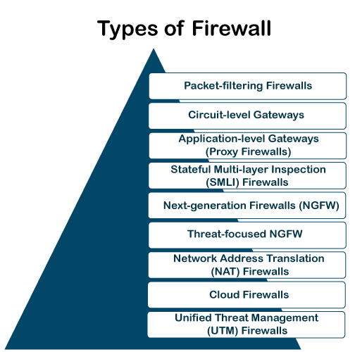

Packet-filtering Firewalls
A packet filtering firewall is the most basic type of firewall. It acts like a management program that monitors network traffic and filters incoming packets based on configured security rules. These firewalls are designed to block network traffic IP protocols, an IP address, and a port number if a data packet does not match the established rule-set.
While packet-filtering firewalls can be considered a fast solution without many resource requirements, they also have some limitations. Because these types of firewalls do not prevent web-based attacks, they are not the safest.

Circuit-level Gateways
Circuit-level gateways are another simplified type of firewall that can be easily configured to allow or block traffic without consuming significant computing resources. These types of firewalls typically operate at the session-level of the OSI model by verifying TCP (Transmission Control Protocol) connections and sessions. Circuit-level gateways are designed to ensure that the established sessions are protected.
Typically, circuit-level firewalls are implemented as security software or pre-existing firewalls. Like packet-filtering firewalls, these firewalls do not check for actual data, although they inspect information about transactions. Therefore, if a data contains malware, but follows the correct TCP connection, it will pass through the gateway. That is why circuit-level gateways are not considered safe enough to protect our systems.

Application-level Gateways (Proxy Firewalls)
Proxy firewalls operate at the application layer as an intermediate device to filter incoming traffic between two end systems (e.g., network and traffic systems). That is why these firewalls are called 'Application-level Gateways'.
Unlike basic firewalls, these firewalls transfer requests from clients pretending to be original clients on the web-server. This protects the client's identity and other suspicious information, keeping the network safe from potential attacks. Once the connection is established, the proxy firewall inspects data packets coming from the source. If the contents of the incoming data packet are protected, the proxy firewall transfers it to the client. This approach creates an additional layer of security between the client and many different sources on the network.

Stateful Multi-layer Inspection (SMLI) Firewalls
Stateful multi-layer inspection firewalls include both packet inspection technology and TCP handshake verification, making SMLI firewalls superior to packet-filtering firewalls or circuit-level gateways. Additionally, these types of firewalls keep track of the status of established connections.
In simple words, when a user establishes a connection and requests data, the SMLI firewall creates a database (state table). The database is used to store session information such as source IP address, port number, destination IP address, destination port number, etc. Connection information is stored for each session in the state table. Using stateful inspection technology, these firewalls create security rules to allow anticipated traffic.
In most cases, SMLI firewalls are implemented as additional security levels. These types of firewalls implement more checks and are considered more secure than stateless firewalls. This is why stateful packet inspection is implemented along with many other firewalls to track statistics for all internal traffic. Doing so increases the load and puts more pressure on computing resources. This can give rise to a slower transfer rate for data packets than other solutions.

Next-generation Firewalls (NGFW)
Many of the latest released firewalls are usually defined as 'next-generation firewalls'. However, there is no specific definition for next-generation firewalls. This type of firewall is usually defined as a security device combining the features and functionalities of other firewalls. These firewalls include deep-packet inspection (DPI), surface-level packet inspection, and TCP handshake testing, etc.
NGFW includes higher levels of security than packet-filtering and stateful inspection firewalls. Unlike traditional firewalls, NGFW monitors the entire transaction of data, including packet headers, packet contents, and sources. NGFWs are designed in such a way that they can prevent more sophisticated and evolving security threats such as malware attacks, external threats, and advance intrusion.

Threat-focused NGFW
Threat-focused NGFW includes all the features of a traditional NGFW. Additionally, they also provide advanced threat detection and remediation. These types of firewalls are capable of reacting against attacks quickly. With intelligent security automation, threat-focused NGFW set security rules and policies, further increasing the security of the overall defense system.
In addition, these firewalls use retrospective security systems to monitor suspicious activities continuously. They keep analyzing the behavior of every activity even after the initial inspection. Due to this functionality, threat-focus NGFW dramatically reduces the overall time taken from threat detection to cleanup.

Network Address Translation (NAT) Firewalls
Network address translation or NAT firewalls are primarily designed to access Internet traffic and block all unwanted connections. These types of firewalls usually hide the IP addresses of our devices, making it safe from attackers.
When multiple devices are used to connect to the Internet, NAT firewalls create a unique IP address and hide individual devices' IP addresses. As a result, a single IP address is used for all devices. By doing this, NAT firewalls secure independent network addresses from attackers scanning a network for accessing IP addresses. This results in enhanced protection against suspicious activities and attacks.
In general, NAT firewalls works similarly to proxy firewalls. Like proxy firewalls, NAT firewalls also work as an intermediate device between a group of computers and external traffic.

Cloud Firewalls
Whenever a firewall is designed using a cloud solution, it is known as a cloud firewall or FaaS (firewall-as-service). Cloud firewalls are typically maintained and run on the Internet by third-party vendors. This type of firewall is considered similar to a proxy firewall. The reason for this is the use of cloud firewalls as proxy servers. However, they are configured based on requirements.
The most significant advantage of cloud firewalls is scalability. Because cloud firewalls have no physical resources, they are easy to scale according to the organization's demand or traffic-load. If demand increases, additional capacity can be added to the cloud server to filter out the additional traffic load. Most organizations use cloud firewalls to secure their internal networks or entire cloud infrastructure.

Unified Threat Management (UTM) Firewalls
UTM firewalls are a special type of device that includes features of a stateful inspection firewall with anti-virus and intrusion prevention support. Such firewalls are designed to provide simplicity and ease of use. These firewalls can also add many other services, such as cloud management, etc.

Which firewall architecture is best?
When it comes to selecting the best firewall architecture, there is no need to be explicit. It is always better to use a combination of different firewalls to add multiple layers of protection. For example, one can implement a hardware or cloud firewall at the perimeter of the network, and then further add individual software firewall with every network asset.
Besides, the selection usually depends on the requirements of any organization. However, the following factors can be considered for the right selection of firewall:

Size of the organization
If an organization is large and maintains a large internal network, it is better to implement such firewall architecture, which can monitor the entire internal network.

Availability of resources
If an organization has the resources and can afford a separate firewall for each hardware piece, this is a good option. Besides, a cloud firewall may be another consideration.

Requirement of multi-level protection
The number and type of firewalls typically depend on the security measures that an internal network requires. This means, if an organization maintains sensitive data, it is better to implement multi-level protection of firewalls. This will ensure data security from hackers.

How to Enable/Disable Firewall

A firewall is the first line of control when it comes to the security of computers. It is designed to keep unauthorized users away from accessing files and resources stored on the computer system. There can be several reasons why a user might want to disable the firewall, especially when a user wants to try another firewall program.

Note: It is not good to disable Windows Firewall unless there is another security program (with additional firewall support) running on the computer.
Disabling the Windows Firewall is quite easy, and it hardly takes around 10 minutes. Let's proceed with the steps to disable a firewall:
Step 1: First, we need to open the Control Panel. There are several ways to do this, but the easiest way is to use a search bar. Therefore, we need to click on the Windows search bar and enter the 'Control Panel'. It will look like the following screen:
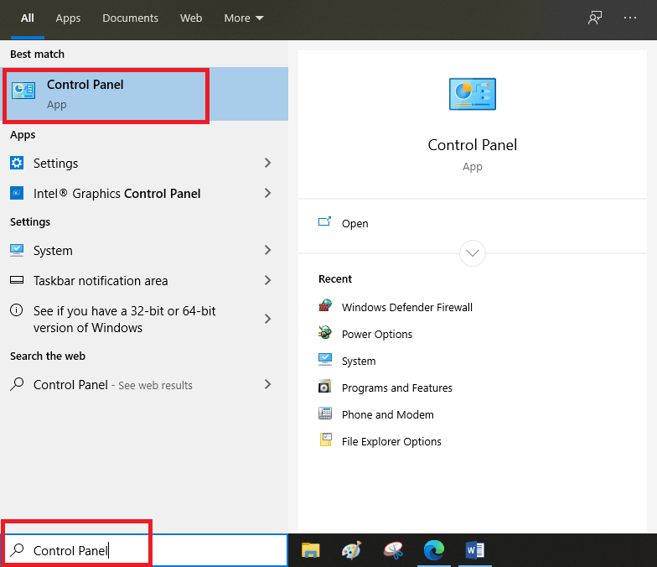
Step 2: After that, we are required to click on the Control Panel to open its settings. The control panel contains the following options:
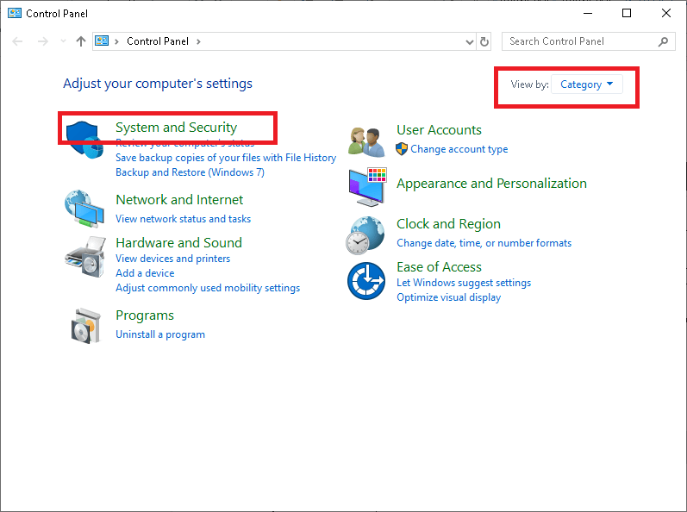
Here, we need to click on 'System and Security'. This option is only visible if the 'view by:' option is set as 'Category'.
Step 3: Next, we need to click on 'Windows Defender Firewall', as shown below:
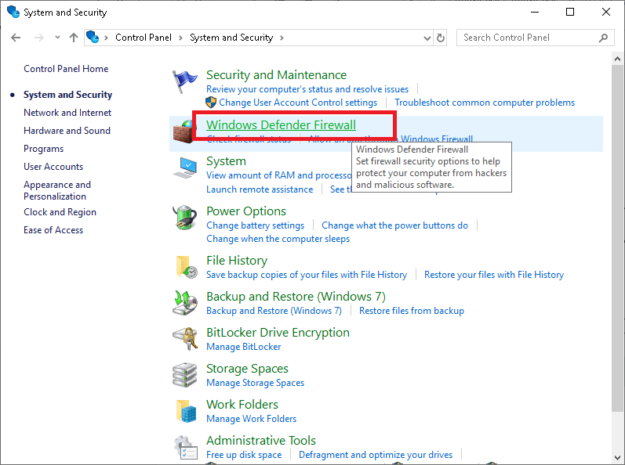

Note: In some computers, the option of 'Windows Defender Firewall' might instead be displayed as 'Windows Firewall'.
Step 4: We are then required to click on 'Turn Windows Defender Firewall on or off'. This option is shown in the left side panel of the screen:
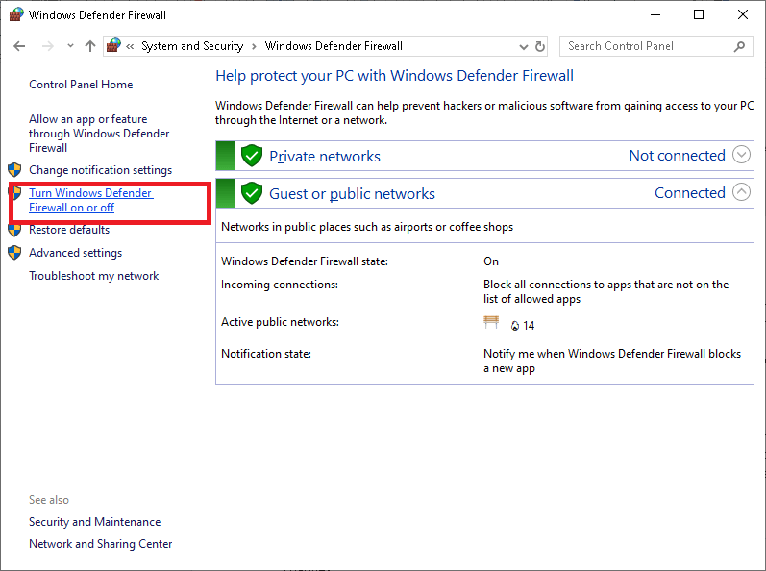
Step 5: On the next screen, we need to click on the circle radio button next to 'Turn off Windows Defender Firewall (not recommended)'.
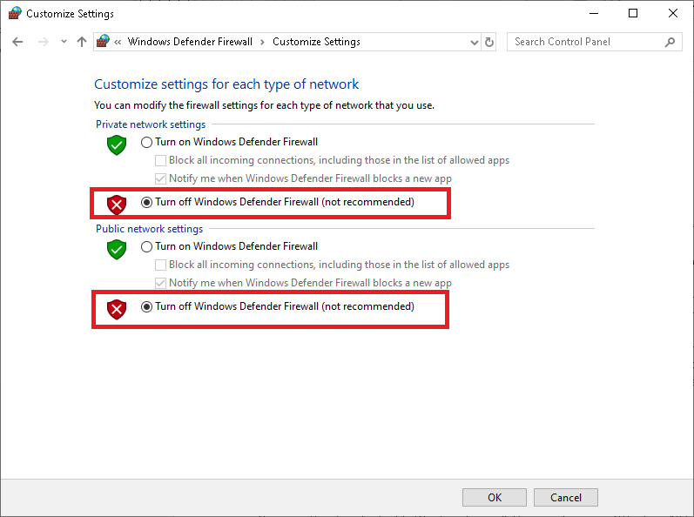
Here, we can select the firewall settings for different types of networks. Using this screen, we can turn off or disable the firewall for private networks, public networks, or both. We need to select the circle radio button next to 'Turn off Windows Defender Firewall (not recommended)' under both the private and the public network settings.
Step 6: After selecting the radio buttons, we are required to click on the 'OK' button to keep the changes.
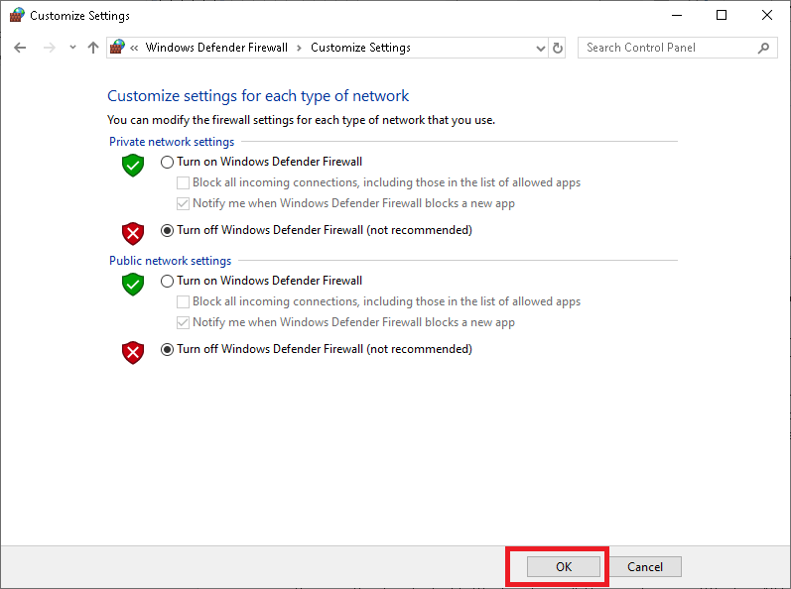
These are the steps to disable Windows Firewall. Here, we have used Windows 10 to describe the complete step by step tutorial. The processes will be the same on Windows 7/8/8.1; however, the user interface may be slightly different.

Caution
Suppose there is any program that is unable to access the Internet. In that case, it is better to allow that specific program through the firewall rather than disabling the entire firewall system. Here are the steps to allow any program through Windows Firewall:
Step 1: First, we need to open a Control Panel.
Step 2: On the next screen, we need to click on 'System and Security'.
Step 3: After that, we are required to click on 'Allow an app through Windows Firewall'. This option is displayed under 'Windows Defender Firewall' option, as shown below:
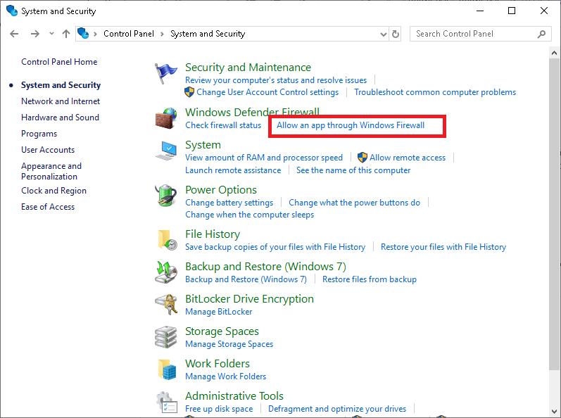
Step 4: After completing the above step, we will get the following screen:
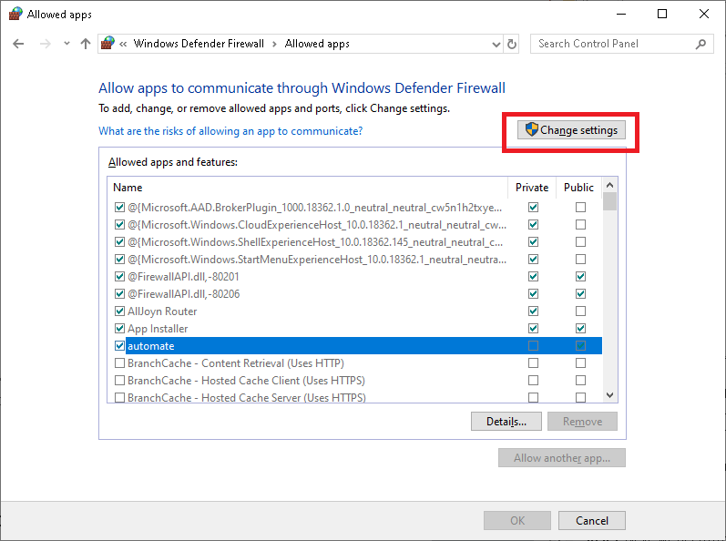
Here, we need to click on the 'Change settings' button. This will allow us to access the list and modify its settings.
Step 5: Under the list of 'allowed apps and features', we can find a specific program to which we want to grant access through the Windows Firewall. After that, we need to select the checkboxes next to that particular program.
Here, we also get options to manage firewall settings for the private network and public network separately. The private box is mostly used for games based on a local area network, while the public box is used to allow the program to access the Internet. Besides, if we don't see a required program in the list, we can use the 'Allow another app' button to add it manually.
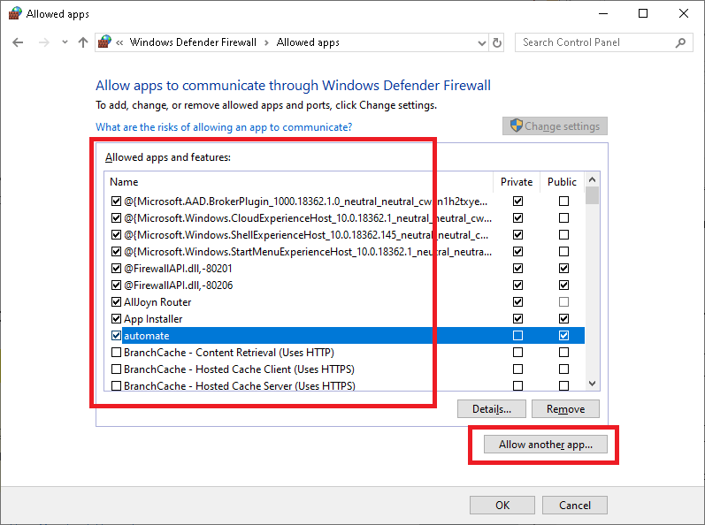
Step 6: Next, we need to click on the 'OK' button to keep the changes.

By using this method, we can enable or disable Windows Firewall for specific software. In simple words, the method helps us specify rules for individual programs to allow access to the Internet
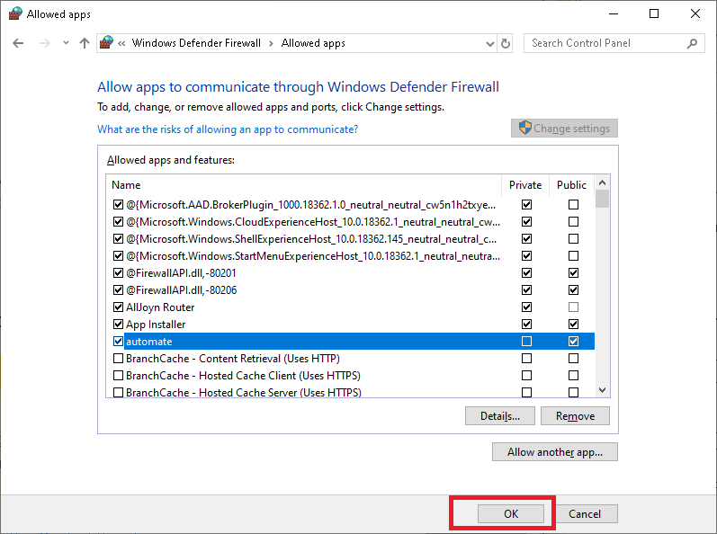

Anti-Virus :
The computer which we use today has become a crucial part of our lifestyle. Without them, it’s almost impossible for our daily works also as our professions. And also when using them we always wanted to make sure safety and privacy, especially from viruses.
Antivirus software is meant to get rid of viruses off your computer. Without an antivirus program, your system is going to be susceptible to viruses and other threats. Aside from removing viruses, antivirus software does produce other major benefits. Whether it’s a desktop utilized in-home or office, it’s essential for antivirus software to be installed in them. While using them users can encounter drawbacks also.
Benefits of Antivirus :
- Virus Protection –
The main role of an antivirus program is to face viruses and other sorts of malware. The viruses won’t only cause damages to your data, it can degrade the general system performance. All of them can happen without your knowledge The antivirus programming introduced on your PC distinguishes and eliminates this malware before they create any damages to your PC.
- Spyware Protection –
Spyware because the name suggests may be quite a malware that spies on your computer stealing all the confidential information. These details also include MasterCard details, passwords, and other financial data. This ultimately results in fraud. The antivirus software has the potential to stop these sorts of spyware attacks.
- Web Protection –
While surfing the web, users can encounter various other sorts of threats. In untrustworthy sites, cyber attackers can gather your MasterCard and checking account details. One among the thanks for overcoming this is often by using antivirus software. Using an antivirus program you’ll protect your valuable pieces of information while surfing online.
- Spam Protection –
Viruses also can enter your computer through means of spam emails and ads. These emails and ads can show up repeatedly albeit you haven’t any interest in it. Once the virus finds thanks to sneak into your PC it causes irreversible damages. An Antivirus works by the way of blocking these spam emails and ads.
- Firewall Feature –
The firewall provides two-way protection. This suggests that regardless of the information that’s sent or received is going to be double-checked here. Hence, hackers cannot enter the system data.
- Cost-Effective –
Even though there are many premium versions of antivirus programs for a monthly/yearly subscription fee, there are some antivirus programs that are completely free from charge. These sorts of antivirus programs offer almost an equivalent level of protection provided by the subscription-based. Albeit you select to afford a premium version, they’re relatively inexpensive.
Drawbacks of Antivirus :
- System Slowdown –
Using an antivirus program means tons of resources from the memory and therefore the disk drive is getting used. As a result, it can drastically slow down the overall speed of the pc. Moreover, the method of scanning also can cause lags within the network.
- No Complete Protection –
If you’re employing a free antivirus program, there’s no guarantee that it’ll provide you the entire protection. Moreover, they’re capable of identifying only certain sorts of threats. So as for acquiring a complete level of protection, you’ve got to use a firewall also.
- Security Holes –
When security holes are present inside the OS or the networking software, it’ll provide an opportunity for the virus to bypass the antivirus software. Unless the user takes action to stay updated, the antivirus software won’t be effective.
- Limited Detection Techniques –
For identifying a possible threat, there is always quite one method available. However, within the case of antivirus programs, it mostly executes the tactic of virus scanning. Sometimes the antivirus programs can offer you false alarms if the scanning matches with the traditional file.
- Frequent Advertisements –
Apart from premium versions of antivirus programs, through some means, the free antivirus software must generate an income. Advertising is one of the ways to realize them. Many sometimes these advertisements degrade the user experience.
- No Customer Support –
Unless you buy the premium version, there won’t be any customer support given to you. Within the event of any problem, the sole thanks to overcoming are through forums and knowledge bases.

Examples of Antivirus softwares
- Avast. ...
- AVG Antivirus Business Edition. ...
- Bitdefender Total Security. ...
- Kaspersky. ...
- McAfee. ...
- Malwarebytes. ...
- Norton. ...
- SecureMac.

Lo14
Cyber Law overview and its objectives, Introduction to Cyber Security Regulations and strategies, Roles of International Law, Basics of ISO27001, Introduction to Indian IT Act 2000, IPR laws, offenses and penalties.

Cyberspace
Cyberspace can be defined as an intricate environment that involves interactions between people, software, and services. It is maintained by the worldwide distribution of information and communication technology devices and networks.
With the benefits carried by the technological advancements, the cyberspace today has become a common pool used by citizens, businesses, critical information infrastructure, military and governments in a fashion that makes it hard to induce clear boundaries among these different groups. The cyberspace is anticipated to become even more complex in the upcoming years, with the increase in networks and devices connected to it.

Cyber security
Cybersecurity denotes the technologies and procedures intended to safeguard computers, networks, and data from unlawful admittance, weaknesses, and attacks transported through the Internet by cyber delinquents.
ISO 27001 (ISO27001) is the international Cybersecurity Standard that delivers a model for creating, applying, functioning, monitoring, reviewing, preserving, and improving an Information Security Management System.
The Ministry of Communication and Information Technology under the government of India provides a strategy outline called the National Cybersecurity Policy. The purpose of this government body is to protect the public and private infrastructure from cyber-attacks.

Cybersecurity Policy
The cybersecurity policy is a developing mission that caters to the entire field of Information and Communication Technology (ICT) users and providers. It includes −
- Home users
- Small, medium, and large Enterprises
- Government and non-government entities
It serves as an authority framework that defines and guides the activities associated with the security of cyberspace. It allows all sectors and organizations in designing suitable cybersecurity policies to meet their requirements. The policy provides an outline to effectively protect information, information systems and networks.
It gives an understanding into the Government’s approach and strategy for security of cyber space in the country. It also sketches some pointers to allow collaborative working across the public and private sectors to safeguard information and information systems. Therefore, the aim of this policy is to create a cybersecurity framework, which leads to detailed actions and programs to increase the security carriage of cyberspace.

Cyber Crime
The Information Technology Act 2000 or any legislation in the Country does not describe or mention the term Cyber Crime. It can be globally considered as the gloomier face of technology. The only difference between a traditional crime and a cyber-crime is that the cyber-crime involves in a crime related to computers. Let us see the following example to understand it better −
Traditional Theft − A thief breaks into Ram’s house and steals an object kept in the house.
Hacking − A Cyber Criminal/Hacker sitting in his own house, through his computer, hacks the computer of Ram and steals the data saved in Ram’s computer without physically touching the computer or entering in Ram’s house.
The I.T. Act, 2000 defines the terms −
- access in computer network in section 2(a)
- computer in section 2(i)
- computer network in section (2j)
- data in section 2(0)
- information in section 2(v).
To understand the concept of Cyber Crime, you should know these laws. The object of offence or target in a cyber-crime are either the computer or the data stored in the computer.

Nature of Threat
Among the most serious challenges of the 21st century are the prevailing and possible threats in the sphere of cybersecurity. Threats originate from all kinds of sources, and mark themselves in disruptive activities that target individuals, businesses, national infrastructures, and governments alike. The effects of these threats transmit significant risk for the following −
- public safety
- security of nations
- stability of the globally linked international community
Malicious use of information technology can easily be concealed. It is difficult to determine the origin or the identity of the criminal. Even the motivation for the disruption is not an easy task to find out. Criminals of these activities can only be worked out from the target, the effect, or other circumstantial evidence. Threat actors can operate with considerable freedom from virtually anywhere. The motives for disruption can be anything such as −
- simply demonstrating technical prowess
- theft of money or information
- extension of state conflict, etc.
Criminals, terrorists, and sometimes the State themselves act as the source of these threats. Criminals and hackers use different kinds of malicious tools and approaches. With the criminal activities taking new shapes every day, the possibility for harmful actions propagates.
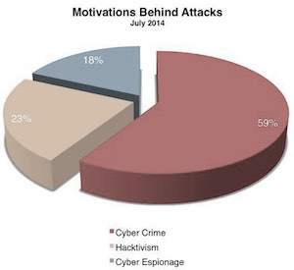

Enabling People
The lack of information security awareness among users, who could be a simple school going kid, a system administrator, a developer, or even a CEO of a company, leads to a variety of cyber vulnerabilities. The awareness policy classifies the following actions and initiatives for the purpose of user awareness, education, and training −
- A complete awareness program to be promoted on a national level.
- A comprehensive training program that can cater to the needs of the national information security (Programs on IT security in schools, colleges, and universities).
- Enhance the effectiveness of the prevailing information security training programs. Plan domain-specific training programs (e.g., Law Enforcement, Judiciary, E-Governance, etc.)
- Endorse private-sector support for professional information security certifications.

Information Technology Act
The Government of India enacted The Information Technology Act with some major objectives which are as follows −
- To deliver lawful recognition for transactions through electronic data interchange (EDI) and other means of electronic communication, commonly referred to as electronic commerce or E-Commerce. The aim was to use replacements of paper-based methods of communication and storage of information.
- To facilitate electronic filing of documents with the Government agencies and further to amend the Indian Penal Code, the Indian Evidence Act, 1872, the Bankers' Books Evidence Act, 1891 and the Reserve Bank of India Act, 1934 and for matters connected therewith or incidental thereto.
The Information Technology Act, 2000, was thus passed as the Act No.21 of 2000. The I. T. Act got the President’s assent on June 9, 2000 and it was made effective from October 17, 2000. By adopting this Cyber Legislation, India became the 12th nation in the world to adopt a Cyber Law regime.

Mission and Vision Cybersecurity Program

Mission
The following mission caters to cybersecurity −
- To safeguard information and information infrastructure in cyberspace.
- To build capabilities to prevent and respond to cyber threats.
- To reduce vulnerabilities and minimize damage from cyber incidents through a combination of institutional structures, people, processes, technology, and cooperation.

Security Standards
PlayNext
Unmute
Current TimeÂ 0:00
/
DurationÂ 18:10
Loaded: 0.37%
Â
Fullscreen
Backward Skip 10sPlay VideoForward Skip 10s
To make cybersecurity measures explicit, the written norms are required. These norms are known as cybersecurity standards: the generic sets of prescriptions for an ideal execution of certain measures. The standards may involve methods, guidelines, reference frameworks, etc. It ensures efficiency of security, facilitates integration and interoperability, enables meaningful comparison of measures, reduces complexity, and provide the structure for new developments.
A security standard is "a published specification that establishes a common language, and contains a technical specification or other precise criteria and is designed to be used consistently, as a rule, a guideline, or a definition." The goal of security standards is to improve the security of information technology (IT) systems, networks, and critical infrastructures. The Well-Written cybersecurity standards enable consistency among product developers and serve as a reliable standard for purchasing security products.
Security standards are generally provided for all organizations regardless of their size or the industry and sector in which they operate. This section includes information about each standard that is usually recognized as an essential component of any cybersecurity strategy.

1. ISO
ISO stands for International Organization for Standardization. International Standards make things to work. These standards provide a world-class specification for products, services and computers, to ensure quality, safety and efficiency. They are instrumental in facilitating international trade.
ISO standard is officially established On 23 February 1947. It is an independent, non-governmental international organization. Today, it has a membership of 162 national standards bodies and 784 technical committees and subcommittees to take care of standards development. ISO has published over 22336 International Standards and its related documents which covers almost every industry, from information technology, to food safety, to agriculture and healthcare.

ISO 27000 Series
It is the family of information security standards which is developed by the International Organization for Standardization and the International Electrotechnical Commission to provide a globally recognized framework for best information security management. It helps the organization to keep their information assets secure such as employee details, financial information, and intellectual property.
The need of ISO 27000 series arises because of the risk of cyber-attacks which the organization face. The cyber-attacks are growing day by day making hackers a constant threat to any industry that uses technology.
The ISO 27000 series can be categorized into many types. They are-
ISO 27001- This standard allows us to prove the clients and stakeholders of any organization to managing the best security of their confidential data and information. This standard involves a process-based approach for establishing, implementing, operating, monitoring, maintaining, and improving our ISMS.
ISO 27000- This standard provides an explanation of terminologies used in ISO 27001.
ISO 27002- This standard provides guidelines for organizational information security standards and information security management practices. It includes the selection, implementation, operating and management of controls taking into consideration the organization's information security risk environment(s).
ISO 27005- This standard supports the general concepts specified in 27001. It is designed to provide the guidelines for implementation of information security based on a risk management approach. To completely understand the ISO/IEC 27005, the knowledge of the concepts, models, processes, and terminologies described in ISO/IEC 27001 and ISO/IEC 27002 is required. This standard is capable for all kind of organizations such as non-government organization, government agencies, and commercial enterprises.
ISO 27032- It is the international Standard which focuses explicitly on cybersecurity. This Standard includes guidelines for protecting the information beyond the borders of an organization such as in collaborations, partnerships or other information sharing arrangements with clients and suppliers.

2. IT Act
The Information Technology Act also known as ITA-2000, or the IT Act main aims is to provide the legal infrastructure in India which deal with cybercrime and e-commerce. The IT Act is based on the United Nations Model Law on E-Commerce 1996 recommended by the General Assembly of United Nations. This act is also used to check misuse of cyber network and computer in India. It was officially passed in 2000 and amended in 2008. It has been designed to give the boost to Electronic commerce, e-transactions and related activities associated with commerce and trade. It also facilitate electronic governance by means of reliable electronic records.
IT Act 2000 has 13 chapters, 94 sections and 4 schedules. The first 14 sections concerning digital signatures and other sections deal with the certifying authorities who are licenced to issue digital signature certificates, sections 43 to 47 provides penalties and compensation, section 48 to 64 deal with appeal to high court, sections 65 to 79 deal with offences, and the remaining section 80 to 94 deal with miscellaneous of the act.

3. Copyright Act
The Copyright Act 1957 amended by the Copyright Amendment Act 2012 governs the subject of copyright law in India. This Act is applicable from 21 January 1958. Copyright is a legal term which describes the ownership of control of the rights to the authors of "original works of authorship" that are fixed in a tangible form of expression. An original work of authorship is a distribution of certain works of creative expression including books, video, movies, music, and computer programs. The copyright law has been enacted to balance the use and reuse of creative works against the desire of the creators of art, literature, music and monetize their work by controlling who can make and sell copies of the work.
The copyright act covers the following-
- Rights of copyright owners
- Works eligible for protection
- Duration of copyright
- Who can claim copyright
The copyright act does not covers the following-
- Ideas, procedures, methods, processes, concepts, systems, principles, or discoveries
- Works that are not fixed in a tangible form (such as a choreographic work that has not been notated or recorded or an improvisational speech that has not been written down)
- Familiar symbols or designs
- Titles, names, short phrases, and slogans
- Mere variations of typographic ornamentation, lettering, or coloring

4. Patent Law
Patent law is a law that deals with new inventions. Traditional patent law protect tangible scientific inventions, such as circuit boards, heating coils, car engines, or zippers. As time increases patent law have been used to protect a broader variety of inventions such as business practices, coding algorithms, or genetically modified organisms. It is the right to exclude others from making, using, selling, importing, inducing others to infringe, and offering a product specially adapted for practice of the patent.
In general, a patent is a right that can be granted if an invention is:
- Not a natural object or process
- New
- Useful
- Not obvious.

5. IPR
Intellectual property rights is a right that allow creators, or owners of patents, trademarks or copyrighted works to benefit from their own plans, ideas, or other intangible assets or investment in a creation. These IPR rights are outlined in the Article 27 of the Universal Declaration of Human Rights. It provides for the right to benefit from the protection of moral and material interests resulting from authorship of scientific, literary or artistic productions. These property rights allow the holder to exercise a monopoly on the use of the item for a specified period.

